Question 1

Q1.1: In how many trials did males court virgin females? In how many trials did males meet but not court virgin females? Seventy and 9, respectively.

Q1.2: Do we have evidence that the mating status of S. ocreata females affects whether males decide to court? How do you know? Yes, because the p-value is less than 0.05.

Q1.3: Provide a figure with an appropriate caption to illustrate the results of the analysis above.
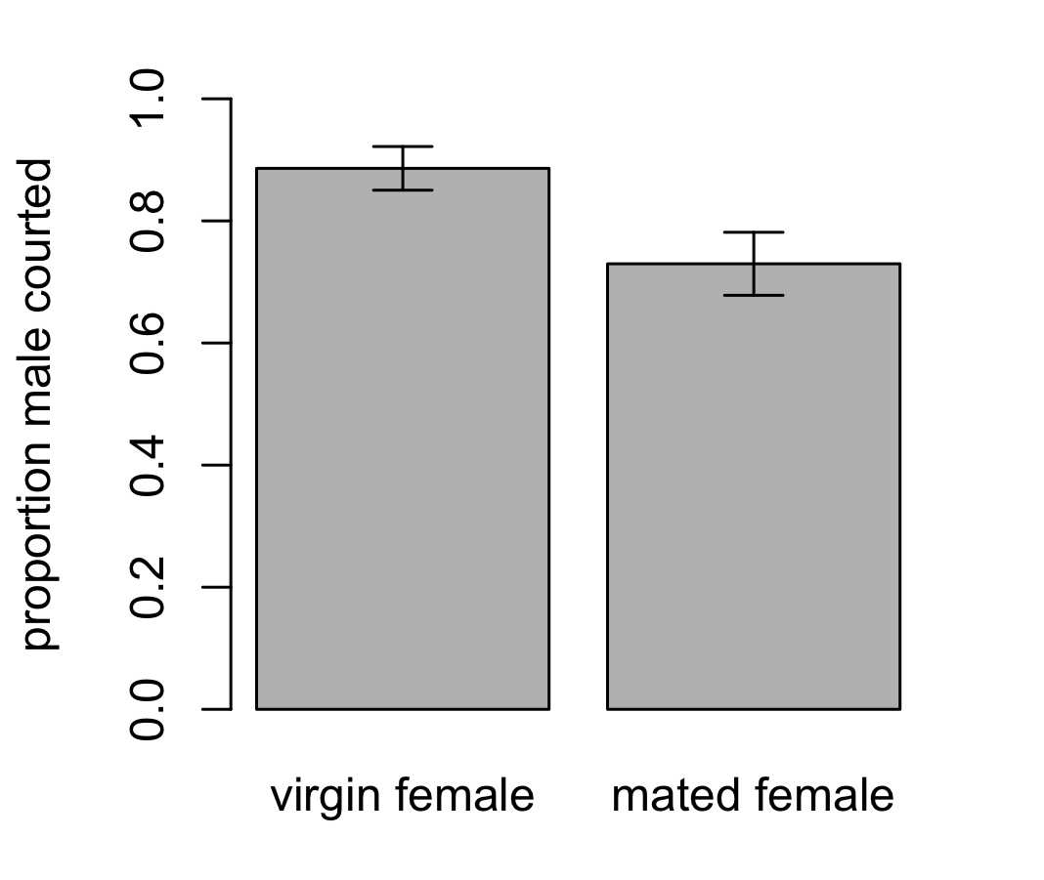
Figure 1.3. The proportions of males that courted when they encountered virgin females and when they encountered females that had previously mated. Error bars show standard errors.

Question 2

Q2.1: Following the logic from question 1, test whether male courtship decisions depended on whether females have recently eaten. Report your results clearly and concisely. We found no evidence that female hunger status affected the probability that males would court them (p = 0.3072).

Q2.2: Provide a figure or table to illustrate your result.

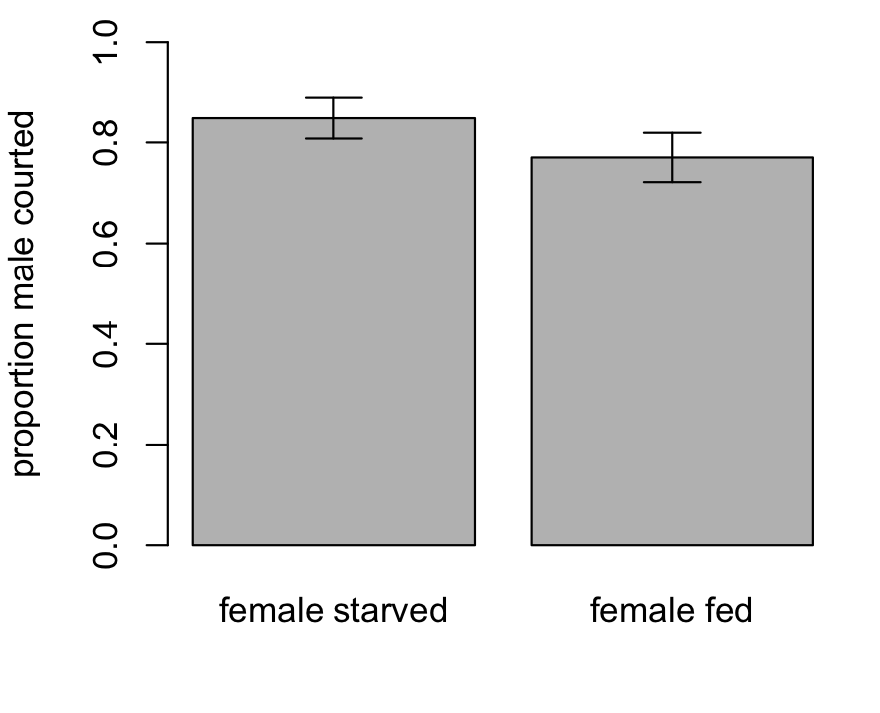
Figure 2.2. The proportion of males that courted when they encountered females that had recently been starved and when they encountered females that had recently been fed. Error bars show standard errors.

Question 3 (Challenge)

Q3.1: Does Meyer and Uetz’s data provide evidence that, among females that were courted, females were less likely to mate if they had already mated than if they were virgin? Among females that were courted, virgin females were more likely to mate than were females that had mated previously (p < 0.0001).
Q3.2: Illustrate your result with a figure or contingency table.
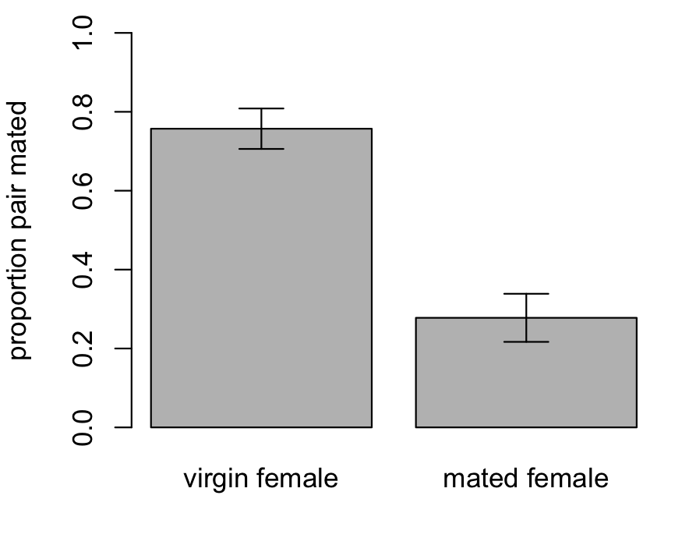
Figure 3.2. The proportions of virgin and previously mated females that mated in trials in which they were courted. Error bars show standard errors.

Question 4

Q4.1: Does Tysall and colleagues data provide evidence that the method used to mark male Drosophila affects their mating success? Report your answer clearly and concisely. Marking method affected the probability that males were chosen as mates (p = 0.0311).

Q4.2: Illustrate your result with a figure or contingency table.
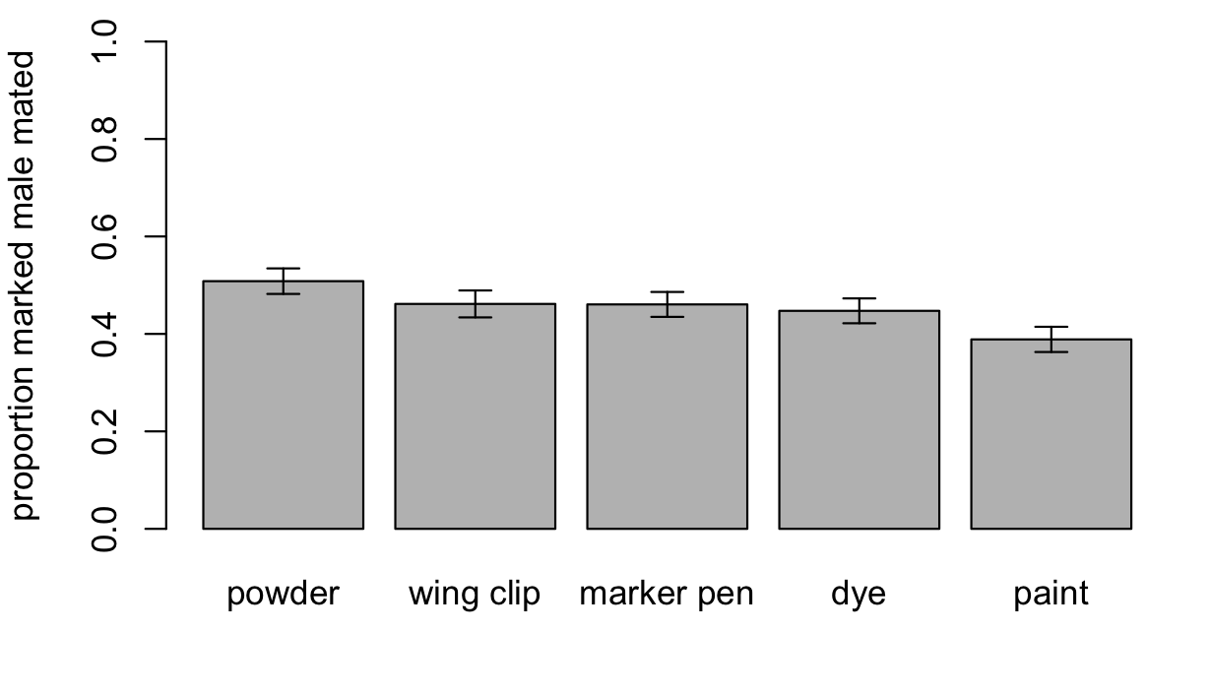
Figure 4.2. The proportions of males with different marker types chosen over unmarked males as mates in mating trials. Error bars show standard errors.

Question 5

Q5.1: Test the hypotheses that i) controlling for pronotum width, males have larger tibial plates than females; and ii) the size of the tibial plate increases with pronotum width faster in males than in females. Report your results clearly and concisely. Does your result support the hypothesis that tibial plates are a signal of male quality in the matador bug? Area of the tibial plate increased with pronotum width (1.99 log(cm²)/log(cm); p < 0.0001). We found weak evidence that males had smaller tibial plates than females (-0.052 log(cm²); p = 0.0848). We found no significant evidence that the size of the tibial plate changes differently in male and female matador bugs (p = 0.2068). This does not support the hypothesis that tibial plates are signals of male mate quality in this species.

Q5.2: Provide a figure to illustrate your result.
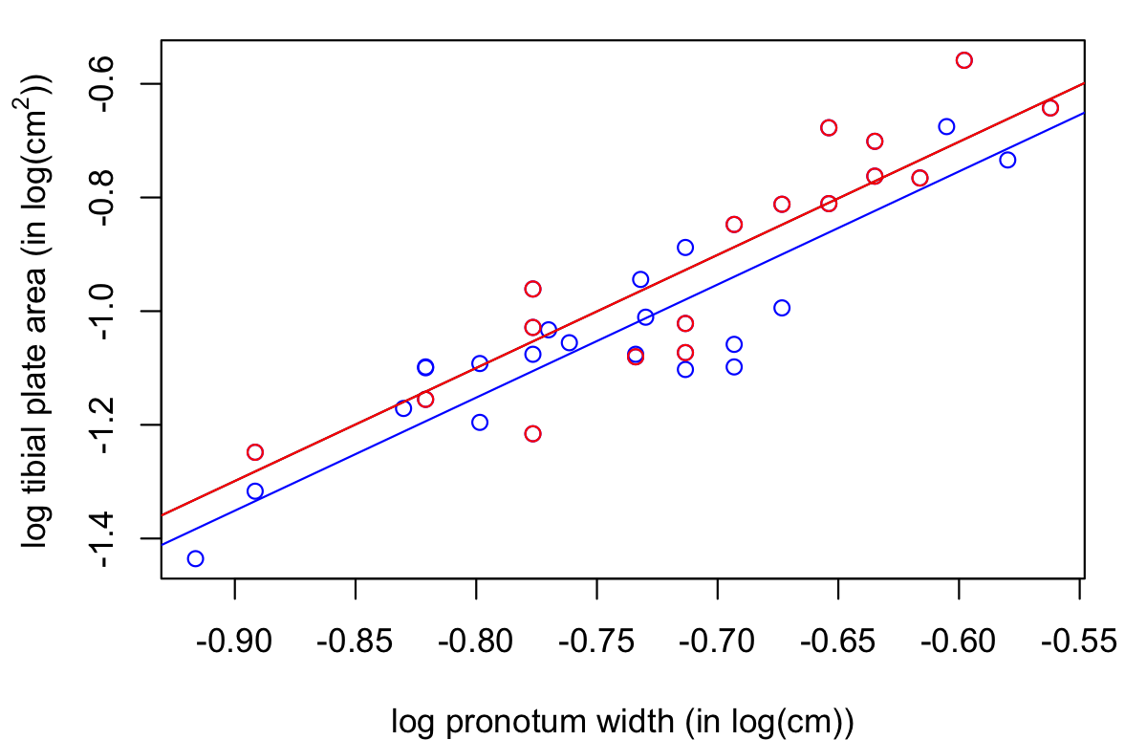
Figure 5.2. Logged tibial plate area as a function of logged pronotum width in male (blue) and female (red) matador bugs.

Question 6

Q6.1: Test the hypothesis that tibia length in A. alipes changes with forewing length. Report your results clearly and concisely. Logged tibia length increased with logged forewing length (0.5085; p < 0.0001).

Q6.2: Test the hypothesis that tibia length in A. alipes changes with hindwing length. Report your results clearly and concisely. Logged tibia length increased with logged hindwing length (0.4584; p < 0.0001).

Q6.3 (Super-challenge): Test the hypothesis that tibia length in A. alipes changes with hindwing length when controlling for forewing length. Report your results clearly and concisely. Can you explain why the result in Q6.3 is different from the result in Q6.1? (The answer is not just that forewing length is in the model – that is given. The question is, why does that matter?) We found no evidence that tibia length increased with hindwing length when forewing length was in the model (p = 0.8632). This is because forewing length and hindwing length are strongly correlated – they contain much of the same information. So, we cannot learn anything about tibia length from hindwing length that we have not already learned from forewing length.

